*SCHISTOSOMIASIS TRANSMISSION*

Timestep [1 month] *t*

Human hosts *i = 1, …, N*

**INITIAL POPULATION**

Population is initialised as the following:

* Initial age distribution based on Uganda lifetables (upper histogram). SAC are about 31% of the population.
* Initial worm distribution in the population (lower histogram)



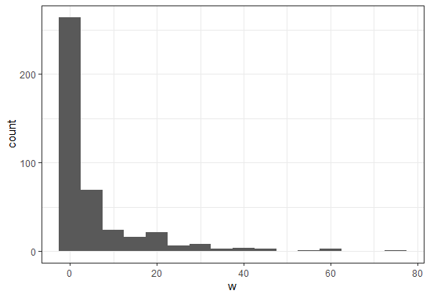

* Individuals are assigned with sex and individual susceptibility to infection (described below)

In the sections below, all the quantities reported with the subscript *i* refer to the *i-th* individual in the simulated population.

At each timestep *t* the following events occur in the same order as described here*:*

**DEMOGRAPHY**

At each time step, births, deaths and aging regulate the demography, according to **birth rates** and **death probabilities** available in literature for Sub-Saharan Africa. The parameters related to the African demography describe an expanding population, as shown in the graph below. Ten stochastic seeds (grey lines) with the mean (black line) are displayed for a simulation of T=200 years.



**Discussion point:** how to keep a constant population size.

I explored this aspect using two different methods:

1. **The reaper.**

The number of **births** for the current month *t*is determined by a Poisson drawn with a rate given as:

where

is the crude **annual** birth rate for Sub-Saharan Africa (per **1000** individuals)

is the population size at timestep *t*

The population is updated with *#births* new individuals, assigned with age=0 and worm load=0. Sex and individual susceptibility are also assigned as described in the next section.

Each month individuals can dye according to an age- and sex- specific **death probability** available from the WHO Demography App for Sub-Saharan Africa.

In case of **death,** the individual is removed from the population.

**Updating age and population quantities:**

After births and deaths occurred, individual age is (monthly) incremented and population size, number of SAC and cumulative exposure accordingly updated.

The reaper (used in WORMSIM) occurs annually and all the times that the population size exceeds a given maximum value, the population is reduced of 10%. This mechanism **preserves the age distribution over time**, but the population dynamics are totally dependent on the chosen input value.

To produce the plot below I am using the reaper mechanism with a max population of 700 individuals. Ten stochastic seeds (grey lines) with the mean (black line) are displayed.

**Population size over time**



1. **Replacing dead individuals**

Each month individuals can dye according to an age- and sex- specific **death probability** available from the WHO Demography App for Sub-Saharan Africa.

In case of **death,** the individual is removed from the population and replaced by a new born: the age is set to zero, the sex re-assigned and the parasitological quantities reset. This mechanism **keeps constant the population size** (to the same value as the initial population), but it **does not preserve the age distribution over time**, since the births are not defined by an actual birth rate.

The two histograms below compare the **age** distribution for the initial population given a Sub-Saharan Africa demography (left panel) and the age distribution at the end of the simulation (500 years) (right panel), assuming only birth/death events and no transmission of the disease.



**INFECTION DYNAMICS**

**EXPOSURE to infection**

**Force of infection acting on individual *i* : number of new worms acquired [nw]**

are considered juveniles and not able yet to reproduce

*cloud* = number of cercariae in the reservoir

*zeta =* overall exposure rate (it mainly drives transmission --> the level of true prevalence)

= age-specific contact (exposure) rates. It could be either step-wise or linear interpolation. It is now implemented as a step-wise function, shown below.

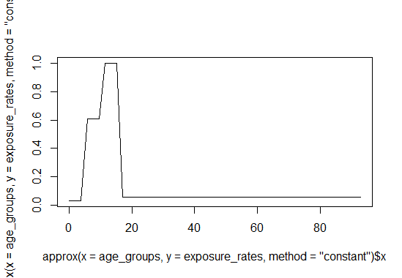

Age

Exposure rate

: level of aggregation of worms in the population, including individual propensities to infection. It has a range in Graham (2021). It affects the prevalence of high intensities of infection.

individual susceptibility to infection. It is assigned at birth and lasts lifelong.

New juvenile worms are assigned sex. Random portion of juvenile worms are males:

**WORMS**

**Mature worms are paired [wp]. Paired worms can produce eggs.**

**Discussion point:** probability of insemination. For now I assume all pairs reproduce.

, number of worm pairs

, expected egg load

: number of male mature worms for human host *i*

: number of female mature worms for human host *i*

: number of detected eggs from human host *i*

: fecundity of female worms in eggs/worm pair. Range studied in De Vlas (1992). It has effect on the shape/slope of the bounce backs.

**Discussion point:** correct definition of . When is it defined as eggs/worm pair and when as eggs/worm pair/slide ? Does this parameter account for accumulation of eggs?

: aggregation parameter for detected egg counts. It drives the discrepancy between true prevalence and egg-based prevalence. De Vlas (1992) takes into account quantity of stool and repeated sample to quantify it.

**CONTRIBUTION to the reservoir**

**Individual contributions []**

**CONTROL**

*(****MDA* assumptions*: 75% coverage, 80% efficacy, annual to pre-SAC and SAC, 10 years)***

If *t* is the time of MDA:

If age of individual *i* is in the target population: with the input **coverage**, the total amount of (**adult) worms** of that individual is **reduced** of a portion equal to the drug efficacy.

**WORMS are updated for the next month:**

The juvenile worms are added and they will be considered mature the next month. (Assumption that can be improved).

A survival portion of male and female adult worms from the previous month is included.

*:* 1 - survival probability of worms from the previous month

: lifespan of an adult worm in the human host [years]

**RESERVOIR/CLOUD**

**Temporary assumption:** snails are not explicitly modelled yet, but a **general cloud** with the two larval stages is included.

The amount of miracidae **[m_in]** entering the reservoir at time *t* is given by:

We assume miracidiae infect snails and spend 1 month within the intermediate host. Thus, the amount of cercariae in the reservoir **[cloud]** at time *t* is further updated with:

We assume particles not infecting humans do not survive in the cloud to the next month. The amount of particles in the cloud is used at next time step to determine the rate of new worms acquisition and the cycle can restart.

**OUTCOMES**

**Prevalence timelines**

1. True prevalence: presence of at least 1 adult worm
2. Egg-based prevalence: portion of population detected with at least 1 egg
3. Egg-based prevalence in SAC: portion of SAC detected with at least 1 egg
4. Prevalence of high intensity of infections: portion of population detected with >400 epg

Discussion point: **mechanisms of density-dependency in Schistosomiasis transmission cycle**

This first version of the model does not include any mechanism of density dependency in the transmission cycle of the disease. The outcome is displayed in **Fig 1** and shows that the model goes to saturation of susceptible individuals. An exploration of the internal dynamics of the model pointed out that the particles in the cloud increase with no upper bound. Without any limiting mechanisms it can reach implausible values going to +∞, even though we consider aging, births and deaths of individuals. This results in extremely high counts of worms in the human hosts and the model does not work.



***Fig 1.*** Prevalence timelines from a simulation of T=200 years. (Polman, de Vlas (2000))

We need limiting mechanisms that can help to set the number of particles in the reservoir to the equilibrium. In two different versions of the model I have explored the following:

* 1. Exponential saturation in the egg production due to density-dependency of worms in the human host
  2. Hyperbolic saturation in the production of cercariae due to saturation of susceptible intermediate hosts or of their carrying capacity

**Version a.**

Under the assumption of density-dependency of worms in the human host, the individual expected egg load is defined as

With : density-dependent fecundity. (Temporary assumption from Graham (2021)).

The results are shown in **Fig 2.**

***Fig 2.*** Prevalence timelines from a simulation of T=200 years. . Ten stochastic seeds (light lines) with the mean (dark line) are displayed.

Under the same assumptions **Fig 3** shows the effect of 10 simulated years of MDA, distributed annually in SAC with a coverage of 75% and an efficacy of 80%.



**Fig 2.** Prevalence timelines from a simulation of T=200 years. α=0.28. Ten stochastic seeds (light lines) with the mean (dark line) are displayed.

**Version b.**

I do not consider here density-dependency in egg production within the human host. I implemented hyperbolic saturation in the production of cercariae due to saturation of susceptible intermediate hosts or of their carrying capacity.

The amount of cercariae in the reservoir **[cloud]** at time *t* is defined through the hyperbolic saturating function:

Where

: is the number of miracidiae released in the reservoir at time *t-1.*

is the number of cercariae produced for each miracidia, in absence of density-dependence. It drives the initial slope of the function.

: is the saturation level for cercariae production. It defines the maximum plateau of the function.

The results are shown in **Fig 3.**



**Fig 3.** Prevalence timelines from a simulation of T=200 years. α=0.28, =0.9 to account for portion of miracidiae dying or not infecting snails, . Ten stochastic seeds (light lines) with the mean (dark line) are displayed. MDA for 30 years is included.

With this version of the model, the amount of particles in the reservoir has an upper bound defined by the *b* parameter and the prevalence goes to the equilibrium. I think it may be difficult to properly estimate *b.* The figure suggests that assumption of saturation of particles in the reservoir mitigates the effect of MDA on the prevalence of infection, with respect to what is observed in **Fig 2**.

**Discussion point:** other possible limiting mechanisms. Those can be explored:

1. Death of individuals due to high burden of worms
2. Explicitly modelling snails life/infection cycle
3. Immunity
4. Modelling worms individually within each human host, to take track of worms’ aging. In De Vlas, Van Oortmarssen (1996) egg production is assumed to be described by a saturating function of worms’ age.

I have tried to improve the model for the last option d. and I have prepared the code with a structure to store worms’ ages, sex and lifespans. Individually tracking the worms for each human host require much more computer memory and computing power. I need to optimize the implementation.